The Proposal of Clinical Management System (CMS)

**Project Idea:**

This proposal addresses the key operational challenges faced by clinics, including scheduling conflicts, inefficient patient history tracking, diagnosis and prescription management, and disorganized inventory control.

To address these issues, the proposed desktop clinical system application is designed to modernize and optimize clinic operations. As the industry grows, clinics need efficient tools to simplify their processes, enhance client relationships, and improve service delivery. This all-in-one solution will automate critical functions such as scheduling, financial management, patient analysis reports and inventory control, while also facilitating seamless communication and accurate record-keeping.

By leveraging technology, this system will enable staff to focus on client care rather than administrative tasks and be more organized, and efficient. Ultimately, the proposed solution aims to enhance both operational efficiency and the overall client experience in clinics.

**Problem statement:**

**Problem definition:**

## Inefficient Appointment Scheduling:

Clinics often struggle with scheduling conflicts, leading to overbooking or under booking of services and professionals. These scheduling issues cause delays, unsatisfied clients, and inefficient use of resources.

## Lack of Centralized Inventory Management:

Managing product inventory for treatments, monitoring expiration dates, and ensuring timely reordering of medications and cosmetics are complex tasks without a centralized system. Manual tracking often leads to stock shortages or overstocking, which negatively impacts operational efficiency. An automated inventory management system is essential for maintaining optimal stock levels and ensuring smooth clinic operations.

## Medical Record-Keeping:

Clinics that rely on manual record-keeping face the risk of errors and data loss, which can compromise the quality of services provided. Accurate and accessible records are crucial for the safe and effective delivery of personalized care. Automating patient records can improve data accuracy and ensure reliable access to essential information.

## Transition from Paper-Based to Digital Archives:

Clinics still dependent on paper records face challenges in accessing and updating client information promptly. This leads to delays in service and increases the potential for errors. Transitioning to automated archives will improve operational efficiency and enhance data editing

## Limited Communication Between Doctors and Nurses:

Poor communication between clinic staff can result in misunderstandings, reduced service quality, and customer dissatisfaction. A system that facilitates better communication is crucial to enhance the services that are provided

**Proposed Solution:**

The proposed solution is a desktop **clinical management system (CMS)** application specifically designed for clinics. This program provides a complete, integrated solution intended to completely transform the clinic's daily operations. The system will enhance patient care and optimize clinic efficiency. The key features of this system, which is designed to meet the specific needs of the clinic, are outlined key featuresbelow:

## Intuitive and User-Friendly Interface

* + **Goal**: To ensure easy adoption by clinic staff at all levels.
  + **Description**: The system will feature a user-friendly interface, enhancing efficiency and user engagement, allowing staff to focus on patient care rather than administrative tasks.

## Centralized Database

* + **Goal**: To centralize all clinic and patient data in a secure, accessible environment.
  + **Description**: The system will securely store patient, clinic, and medical data, enhancing data accuracy, and security.

## Smart Appointment Scheduling

* + **Goal**: To simplify appointment management and minimize scheduling conflicts.
  + **Description**: The CMS will include an intelligent appointment scheduling system that automatically adjusts for staff availability, treatment time, and resource allocation. It will

prevent appointment overlap and double-booking, improving the clinic’s overall efficiency. Automated reminders will be sent to both staff and patients via SMS, email or app notifications.

## Digital Patient Record Management

* + **Goal**: To create a seamless, paperless system for managing patient data.
  + **Description**: The CMS will implement a secure, digital patient record management system that stores patient history, including medical histories, and treatment preferences, this will improve the quality of patient care through more personalized and informed treatment decisions.

## Automated Inventory Management System

* + **Goal**: To ensure optimal inventory control and reduce waste.
  + **Description**: The CMS will include an automated inventory management tool that tracks stock levels in real time, monitors product usage, and generates alerts for low stock or impending expiration.

## Efficient Patient Flow Management

* + **Goal**: To enhance the patient's experience through improved flow management.
  + **Description**: The CMS will include an advanced patient flow management system to streamline patient check-ins, minimize waiting times, and optimize the allocation of medical staff. By managing patient appointments and waiting areas

## Functional requirements: -

* + **Login Process**:

-Nurses, doctors, and administrators **shall** enter their credentials.

-The system **shall** authenticate the credentials and confirm success if they are valid.

## Nurse Dashboard:

-Nurse **shall** check the availability of appointments.

-Nurse **shall** confirm and book appointments.

-Nurse **could** add new patient

- Nurse **should** view the patient's information.

- Administrators **shall** manage user roles within the system.

## Appointment Management:

-Users **shall** view confirmed appointments.

- Nurses and doctors **shall** be able to schedule, update, and cancel appointments.

-The system **shall** notify the user that the appointment is confirmed.

## Doctor Dashboard:

-Administrators **shall** manage user roles within the system.

-Doctors **shall** view upcoming appointments and their details.

-Doctors **shall** access patient records to retrieve information.

-Doctors **shall** write the prescription electronically.

## Patient Records:

-Doctors **shall** update medical notes related to the patient.

-Doctors **shall** create or update prescriptions and plans as necessary.

-Doctors **should** view or add lab results to maintain comprehensive patient data.

**Non-functional requirements: -**

# Performance

-The system **shall** respond to user actions within 2 secondsunder normal load conditions.

-The system **should** support up to 100 concurrent userswithout degradation in performance.

# Security

-User credentials **shall** be secure during transmission and storage using industry-standard securities options.

-The system **shall** enforce role-based access control to restrict users to their assigned roles.

-Session timeout **should** occur after 15 minutesof inactivity.

# Usability

-The user interface **shall** be intuitive and easy for non-technical users such as nurses and doctors.

-User error messages **should** be descriptive, helping users quickly resolve issues.

# Data Integrity

-All data updates, such as appointments, medical notes, and user roles, **shall** be recorded accurately and without loss.

-Data transactions **shall** comply with (Atomicity, Consistency, Isolation, Durability) principles

**User personas:**

**Name**: Dr. Yasser Helmy   
**Role**: Plastic surgeon  
**Age**: N/A  
**Location**: Giza, Egypt  
**Goals**: Wants to manage patient appointments efficiently, access medical history quickly, and ensure smooth coordination with the front office staff.  
**Pain Points**:

* Wastes time searching for patient records.
* Faces frequent errors in scheduling due to miscommunication.  
  **Behaviors**:
* Comfortable with basic technology but prefers systems that are simple and intuitive.
* Uses a computer for medical record updates and appointment scheduling

**Name**: Aya  
**Role**: Nurse  
**Age**: N/A  
**Location**: Giza, Egypt  
**Goals**:

* Deliver patient care efficiently without administrative delays.
* Access and update patient information quickly at the point of care.
* Coordinate seamlessly with doctors and other staff to improve patient outcomes.

**Pain Points**:

* Wastes time searching for patient records.
* Struggles with scheduling conflicts and unclear shift assignments

**Behaviors**:

* Works in a fast-paced environment, often under pressure.
* Uses computers or tablets for patient documentation but prefers intuitive interfaces.

**Class Diagram:**

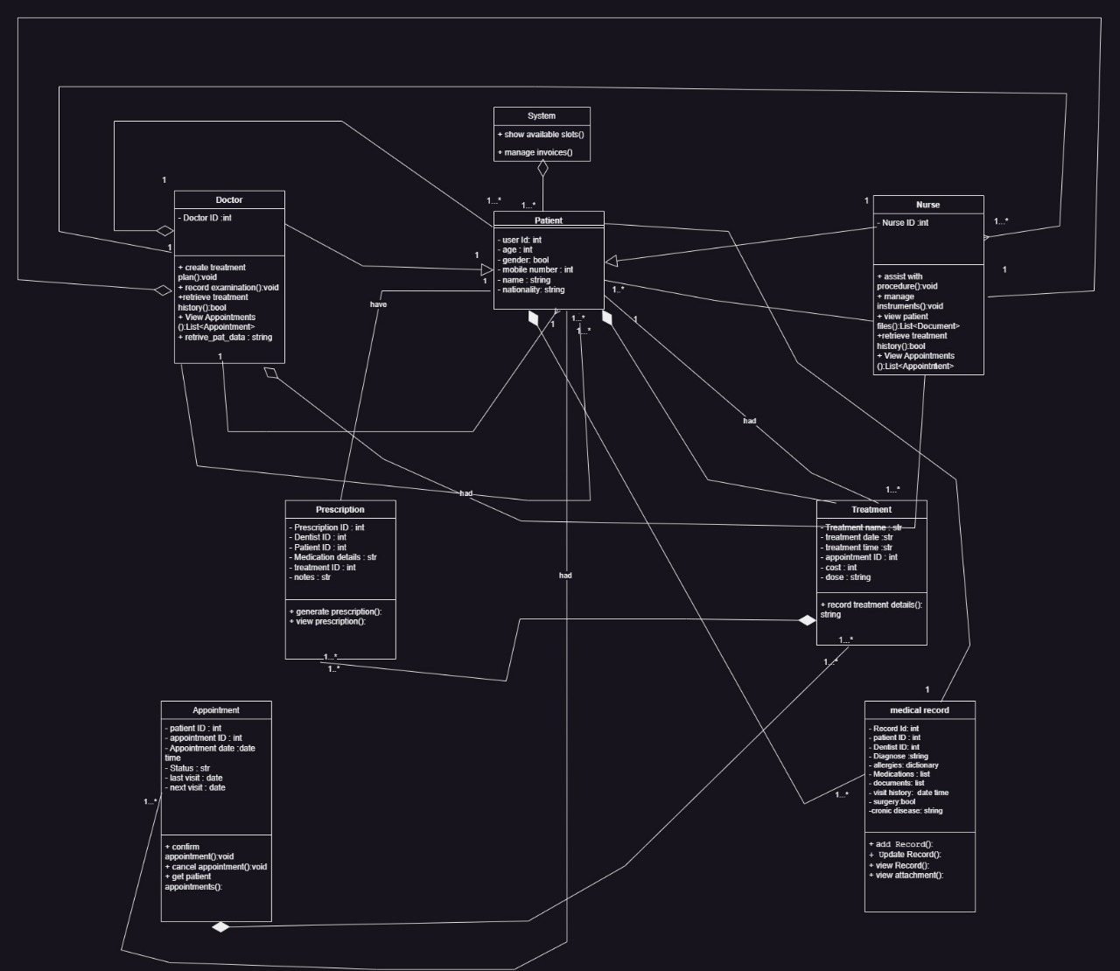

**Architecture diagram**

**Wireframes (Frontend Design Drawings)**

1. **Login Screen**
2. **Doctor Dashboard**
3. **Nurse Dashboard**
4. **Appointment Calendar**
5. **Patient Data**
6. **Reset Password**

**Use Case Diagram**

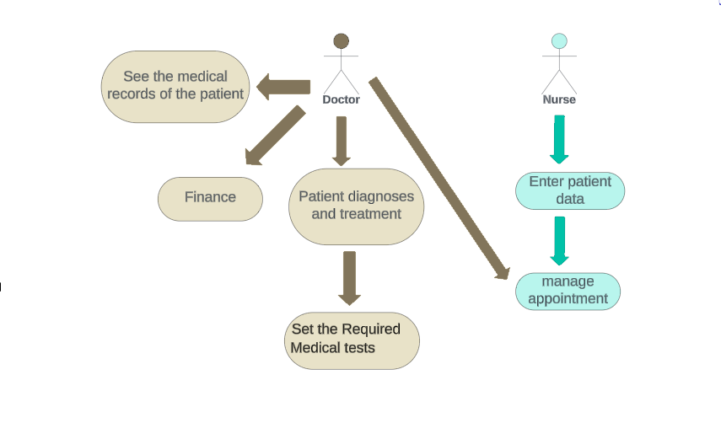

**Conclusion**

|  |  |
| --- | --- |
| **Team members:** Mohamed shady | 221001618 |
| Sandy melad | 221001665 |
| Yousif Metwally | 221000471 |
| Malak khalifa | 221001213 |
| Alaa sari | 221001779 |

The Clinical Management System (CMS) will modernize clinics by solving key operational problems with advanced technology. It will simplify scheduling, manage client data, and track inventory helping clinics run more efficiently, satisfy clients and stay successful in the long term